**1. How do I determine my salary and any applicable compensation?**

**Please be advised that any employee hired after September 1st, 2024 will be automatically placed on a 21-pay period cycle (which means your pay will not be spread over the summer months) and will have an opportunity to change in the summer of 2025.**

**If you are not a new teacher and have previous years of certified teaching experience, be sure to complete the Salary Step/Grade Certification form in your onboarding paperwork. Please note that your step and salary will require verification of your official, outside service credit within 30 days of your effective date (read on for more information about compensation and step verification).**

Regularly appointed Teachers and Long Term Subs (LTS) are paid based on the Teacher's Salary Schedule (see far-right column of table below), which is negotiated by the Providence Teachers Union (PTU). Long Term Subs in Pool (LTSP) are also part of the Providence Teachers Union, but paid at a rate of $225/day in their first year (see section 1a for more details).

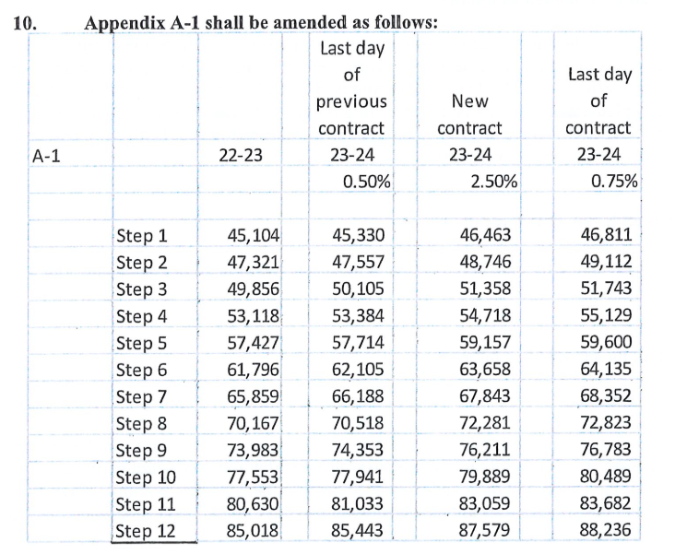

Your step placement corresponds to your salary and qualifying work experience. Teachers will move up one salary step for each full year (at least 135 days) of certified teaching completed. **Step increases for teachers only occur twice a year: February or September.**

*\*\*\*Teachers who start after 11/1/2024 will be on a February increment unless prior experience is provided\*\*\**

In addition, educators with additional credit hours can also qualify for professional advancement in accordance with the following schedule:

* + Bachelor’s + 30 Hours $2,955
  + Master’s $3,355
  + Master’s + 30 $3,757
  + Doctorate $4,157

PPSD accepts up to a maximum of 12 years of inside and outside service credit as “qualifying work experience”.

* *Outside Service*: PPSD issues outside service credit for any employee who has worked at least 135 days as a licensed, full-time educator in another district in one school year. Please send your former employer the [official PPSD outside service form](https://drive.google.com/file/d/1gS6-oT3s_pbwBLF13B_l3682OseI_gGy/view?usp=sharing) and then have it scanned and emailed back to [onboarding@ppsd.org](mailto:onboarding@ppsd.org).
* *Inside Service*: If a former employee returns to the PTU, they will receive credit for past certified experience, inclusive of LTS (long term sub certified) employment, if they had previously worked a full calendar year.

In addition, there are certain employees working in hard-to-fill areas that will receive compensation above their base salary:

* All certified School Psychologists will receive $200 above base salary.
* All teachers of Special Education classes will receive $500 above base salary. This includes social workers, school psychologists, and school speech language pathologists.
* All teachers of ELL/Bilingual classes will receive $800 above base salary.

Loan Forgiveness: All educators of color are also eligible to apply for loan forgiveness through the Rhode Island Foundation that awards $25,000 in loan repayment over the course of three years. Please contact [cynthia.ramirez@ppsd.org](mailto:cynthia.ramirez@ppsd.org) to receive more information on the application process.

**1b. How does pay work for Long Term Subs, Long Term Subs In Pool, Certified Retiree Subs or Certified Retiree Administrators?**

If you are a long term sub (LTS), you are a certified teacher covering for a specific vacancy in the district and will follow the same process for pay as any regular teacher would.

If you are a long-term sub in-pool (LTSP), you are eligible to be placed anywhere in the district and will be paid at a rate of $225/day. After 68 consecutive days in an assignment in your area of certification in one semester, you will be eligible to be placed on the teacher pay scale (LTS) retroactive to the start of the first day in the assignment. If you work a total of 68 days in varying assignments in two semesters, you will advance to a $244 day (Step 2) the following year. You will need to complete the [Outside Service Form](https://drive.google.com/file/d/1gS6-oT3s_pbwBLF13B_l3682OseI_gGy/view?usp=sharing) to determine step and pay scale. LTSP’s are considered part of the teacher’s union and are eligible for medical benefits.

If you are a certified retiree substitute, you will be paid at a rate of $244/day.

If you are a certified retiree administrator for operational support purposes, you will be paid at a rate of $354/day.

**1c. How can I validate my grade and step?**

Once you’ve accepted your job offer, please:

* Request that all official transcripts you may have are sent directly by the credit granting institution(s) to [onboarding@ppsd.org](mailto:onboarding@ppsd.org) electronically (faster) OR by mail to: Providence Public Schools, Attn: Human Resources, 797 Westminster Street, Providence RI 02903.
* Send the [Outside Service Form](https://drive.google.com/file/d/1gS6-oT3s_pbwBLF13B_l3682OseI_gGy/view?usp=sharing) or the [Higher Education Outside Service Form](https://drive.google.com/file/d/1ZFigwBPEYlUjjORBE8XYYloBs91J4Az4/view?usp=sharing) to previous employer(s). Former supervisor(s) and/or HR representatives can fill out and return the form to [onboarding@ppsd.org](mailto:onboarding@ppsd.org).

In the event you are also uncertified (see below) for your position you will be paid at the Step 1 rate or the LTSP rate until your emergency certification is issued. The resources above should help you to evaluate your expected step, professional advancement pay, and any additional compensation until HR receives your official documentation.

**2. What if I am currently unlicensed or not appropriately licensed for my position?**

Teachers, Long Term Subs and Long Term Subs in Pool who are not licensed through the Rhode Island Department of Education for their positions are eligible to be hired on a temporary basis under an emergency certificate or expert residency.

If you are unlicensed candidate, you will need to complete the following before receiving your official award letter:

* If you do not require an emergency certificate: apply for the appropriate license on the [Ride Portal](https://portal.ride.ri.gov/Account/Login) and follow the instructions from RIDE re: licensure.
  + If you have questions about applying for certification, you can [book an appointment](https://outlook.office365.com/owa/calendar/ECERcertsppsdorgCertificationMeeting@ppsd.org/bookings/) to start the process
* If you do require an emergency certification: schedule an in person licensure kick-off meeting by emailing [ECERcerts@ppsd.org](mailto:ECERcerts@ppsd.org). During this meeting, you will be required to make a licensure completion plan to ensure you remain on track for completing your requirements. **Please be advised that this is a required meeting.**
* If you are seeking a license via other means, please consult the RIDE website [here](https://www.ride.ri.gov/TeachersAdministrators/EducatorCertification/PathstoCertification.aspx#23210-ri-approved-programs).

Emergency Certifications and Expert Residencies are valid for one academic year. If a candidate hired on an emergency has not obtained full licensure or met their renewal requirements by February 7th of the 2024-25 academic year, they will not be eligible to be automatically renewed into the position for the following academic year. In this case, they’ll need to reapply to their position when it is posted publicly in March.

**2a. How will my pay work until my certification is issued?**

New teachers who have fulfilled all of their onboarding requirements and supplied Human Resources with all of their required information will be placed at a minimum of step one salary with benefits. Upon the issuance of certification, salaries can be adjusted to reflect the appropriate step based on experience. If the RI Department of Education denies a teaching certificate for a candidate, their salary will be reduced to the Perdiem Substitute rate or the Long Term Substitute in Pool (LTSP) rate. Please note, any educator working under a certificate issued after November 8, 2024 will not receive a year of tenure for the 24-25 school year. Additionally, if an educator starts before they are fully certified, their seniority date will be the date they become fully certified.

**3. What Happens Next (After I Accept My Contingent Job Offer)?**

Upon acceptance of your contingent employment offer, you will be assigned a checklist of paperwork to be completed in our electronic onboarding system. You will receive an automated email with a link to access the checklist. You must also review the [PPSD Employee Handbook](https://www.providenceschools.org/cms/lib/RI01900003/Centricity/Domain/230/Employee%20Handbook-112421.pdf).

Please note that you will receive a letter in the mail with information regarding retirement.

After you attend your welcome session and your BCI has cleared, the staffing team overseeing your hire will reach out to you and your School Leader/Department Head with your effective start date and an email titled “Your Hire has been completed”. This means that your hire is complete and you are officially authorized to begin working as of your effective start date. This email will be the greenlight for you to formally submit your Health Insurance forms to the City of Providence Benefits Department.

System Access Form: Please allow up to 72 hours from the time you receive your award letter to receive access to your emails, Skyward, Novatime, and other systems. Your administrative team will fill the form out for you in order for IT to grant you access.

**4. How do I enroll in health insurance?**

Please note: you cannot enroll in insurance until you’ve accepted your job offer and have been issued an employee ID number through the Office of Human Resources.

Enrollment forms, pricing, and more information can be found on the [City of Providence Website](http://www.providenceri.gov/hr/benefits), but we have also compiled the essential documents for teachers and Long Terms Subs [here](https://drive.google.com/drive/folders/1nSobdDcWDxIHBvQi4ZB0DUwLZTFY8LLj?usp=sharing). The essential documents for Long Term Subs In Pool can be found [here](https://drive.google.com/file/d/1EJXZ1wXNNMI6fbMY1tzs0UUQu65oQsI7/view?usp=sharing). Completed forms can be mailed, emailed or faxed. If faxed, please call the Health and Benefits Office at the City to confirm receipt.

Mailing Address:

City of Providence

Benefits Department Phone: 401-680-5281

PO Box 1656 Email: [benefits@ppsd.org](mailto:benefits@ppsd.org)

Providence, RI 02901 Fax: 401-680-5281

Deadline: You have **30 days** from your effective date to enroll in health benefits. If you fail to enroll, you must wait until open enrollment to enroll, typically in the spring, or with a qualifying life event.

Coverage: Coverage begins the first day of the month following your hire date (if hired 3/2, your effective date would be 4/1; if hired 4/1, your effective date is 5/1)

Coordination of Benefits: Please take note of the [Coordination of Benefits (COB)](https://drive.google.com/drive/folders/1nSobdDcWDxIHBvQi4ZB0DUwLZTFY8LLj) provision which applies to employees who have working spouses or qualified ex-spouses who have access to health coverage through his/her employer.

Still have questions? Please contact us at [onboarding@ppsd.org](mailto:onboarding@ppsd.org).